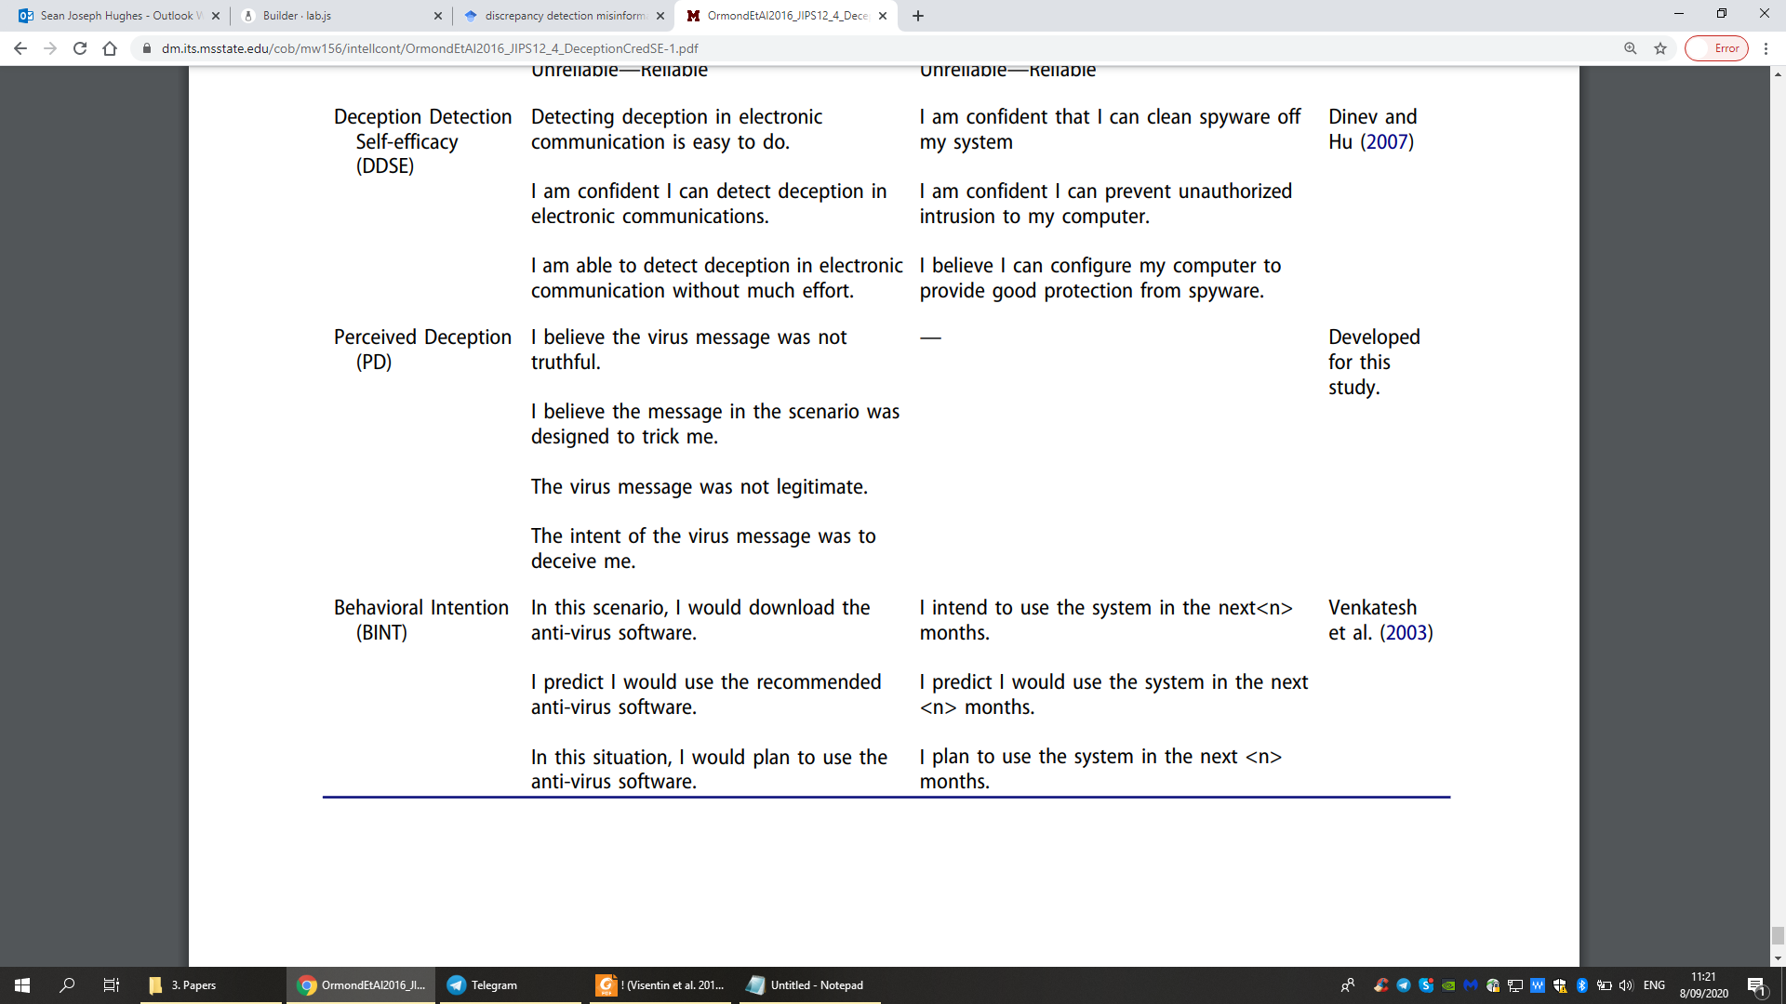

(1 = Strongly Disagree, 2 = Disagree, 3 = Neutral, 4 = Agree, and 5 = Strongly Agree).

**Deception Detection Self-Efficacy** Scale 1 2 3 4 5

Detecting when I’m being deceived is easy to do.

I am confident that I can detect when I’m being deceived.

I am able to detect deception without much effort.

**Perceived Deception** (PD) 1 2 3 4 5

The things Chris said in the video were not truthful.

I believe the things that Chris said in the video were designed to trick me.

The video was not legitimate.

The intent of the video was to deceive me.

(1 = Strongly Disagree, 2 = Disagree, 3 = Neutral, 4 = Agree, and 5 = Strongly Agree).

**Behavioral Intention** (BINT) 12345

If I were browsing YouTube and encountered Chris’ video I would support him by clicking the ‘share’ button (i.e., share his video with other people).

Chris has just started to make these videos and wants to become a YouTuber. Imagine that you encountered his video on YouTube. I would ‘subscribe’ to his channel to learn more about him.

I would recommend Chris’ videos to others.

source trust: can I trust the person telling me it? how much do you trust what researchers tell you in studies

content veracity: is the video true?

drop conspiratorial beliefs as the content in this case does not warrant it

same for overclaiming

replace with questions about capacity to detect lies, reflexive open mindedness, fake news discernment

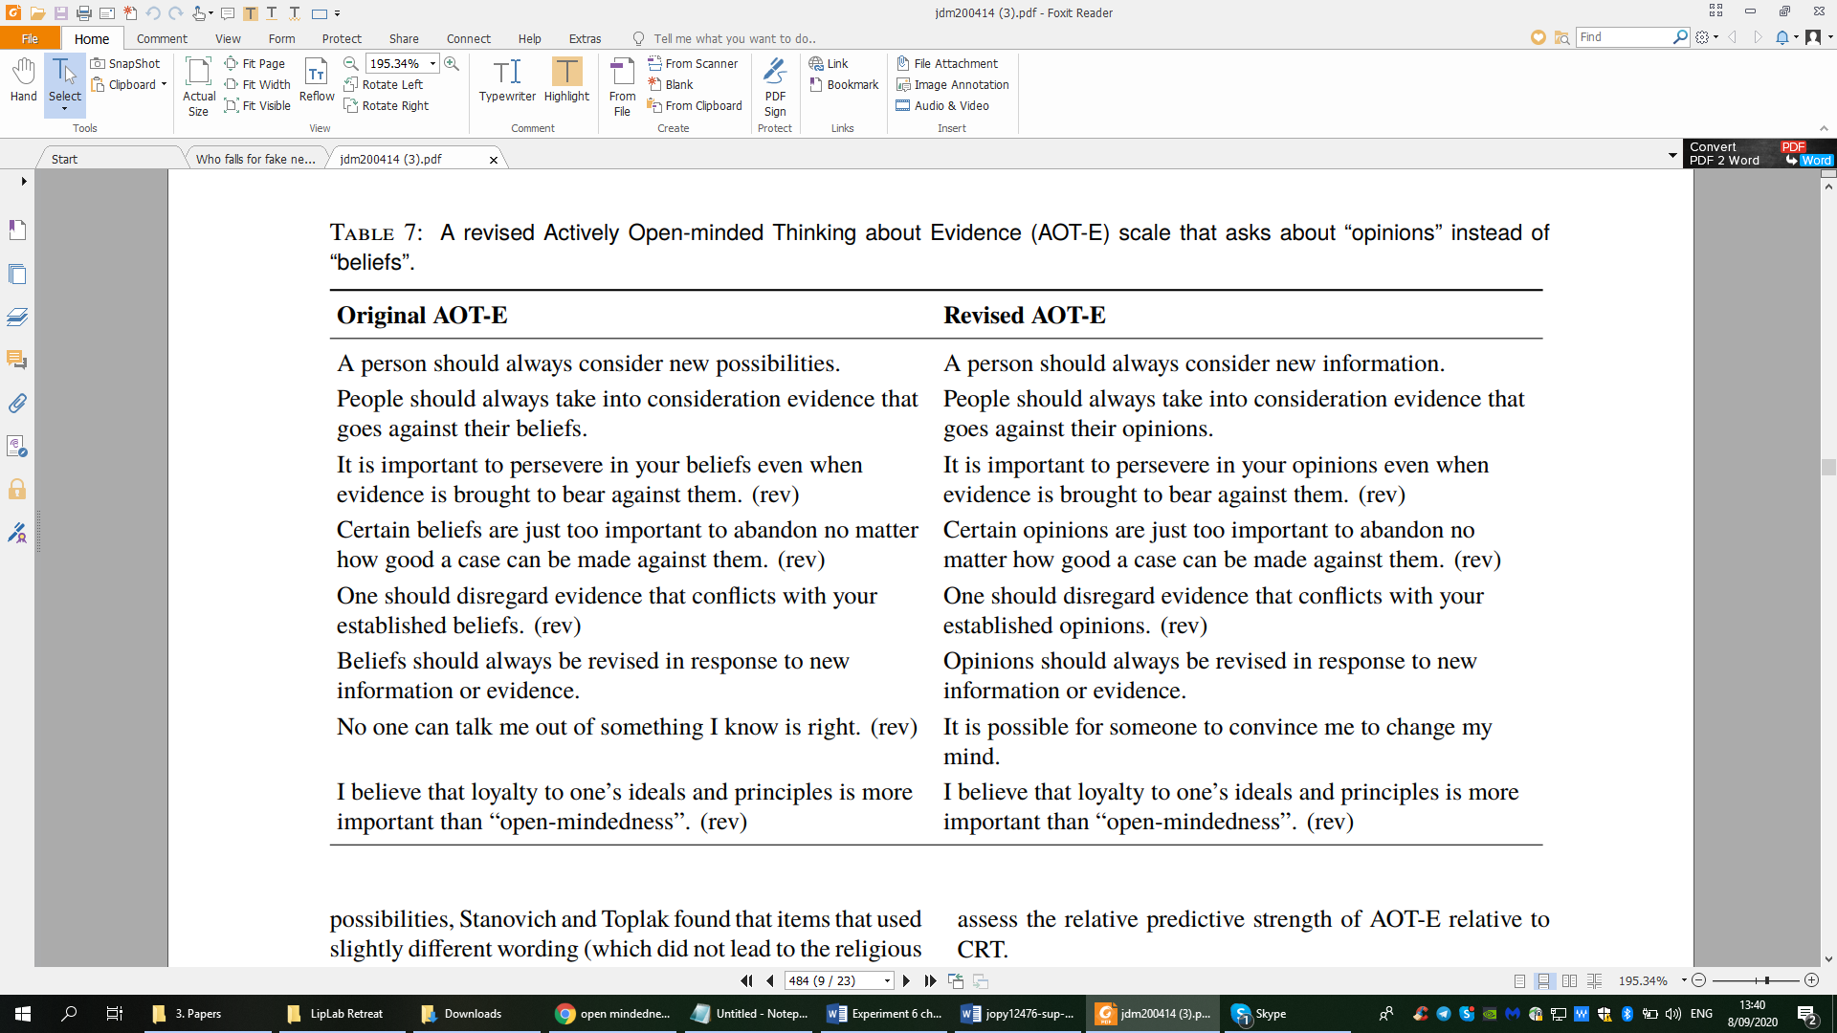

Items 3, 4, 5, 7 & 8 are reverse scored

Participants responded on a scale from 1) Strongly disagree to 6) Strongly agree.

Also include susceptibility to fake news measure

This way can see if the sme people who fall for fake news also fall for Deepfakes.

Pennycook and Rand (2018)

(a) “Have you seen or heard about this story before?” (response options: no/unsure/yes), (b) “To the best of your knowledge, how accurate is the claim in the above headline?” (response options: not at all accurate/ not very accurate/somewhat accurate/very accurate), and (c) “Would you consider sharing this story online (for example, through Facebook or Twitter)?” (response options: I would never share something political online (data removed), no, maybe, yes).

 six-point scale (1 = Strongly disagree, 6 = Strongly agree)

